**Graphing Logarithms**

**TASK 1:**

On the set of axes below, graph and label the following:

    

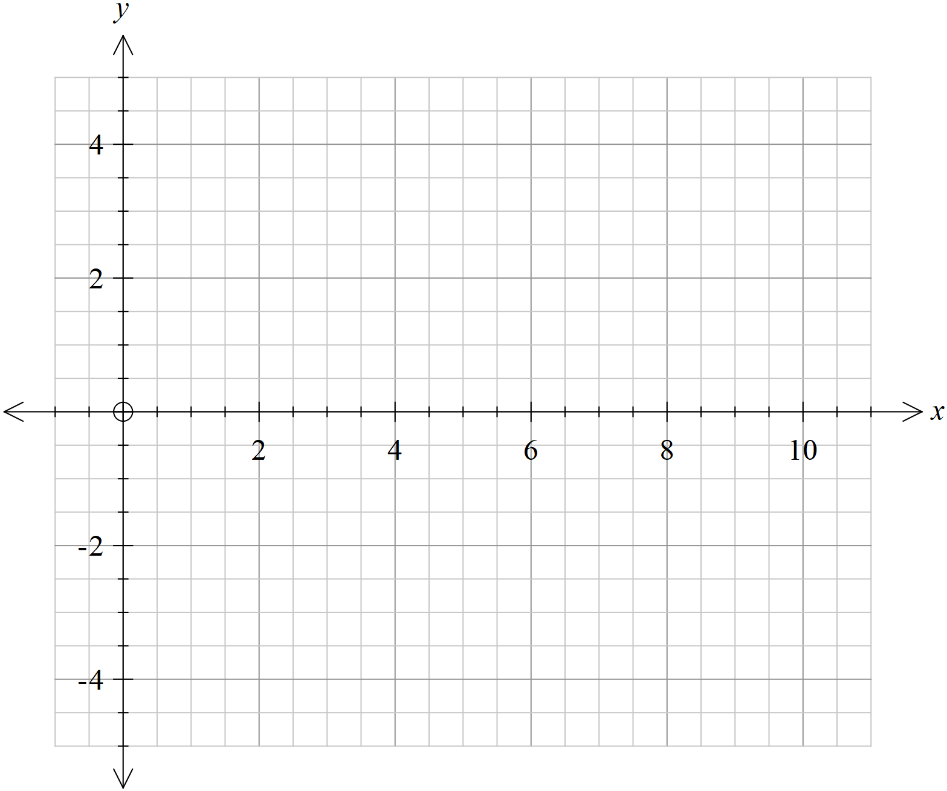

1. What features do all the log graphs share?
2. In what ways are they different?
3. Where does each graph cross ?
4. Why is this the case?

**TASK 2:**

On the set of axes below, graph and label the following:

    

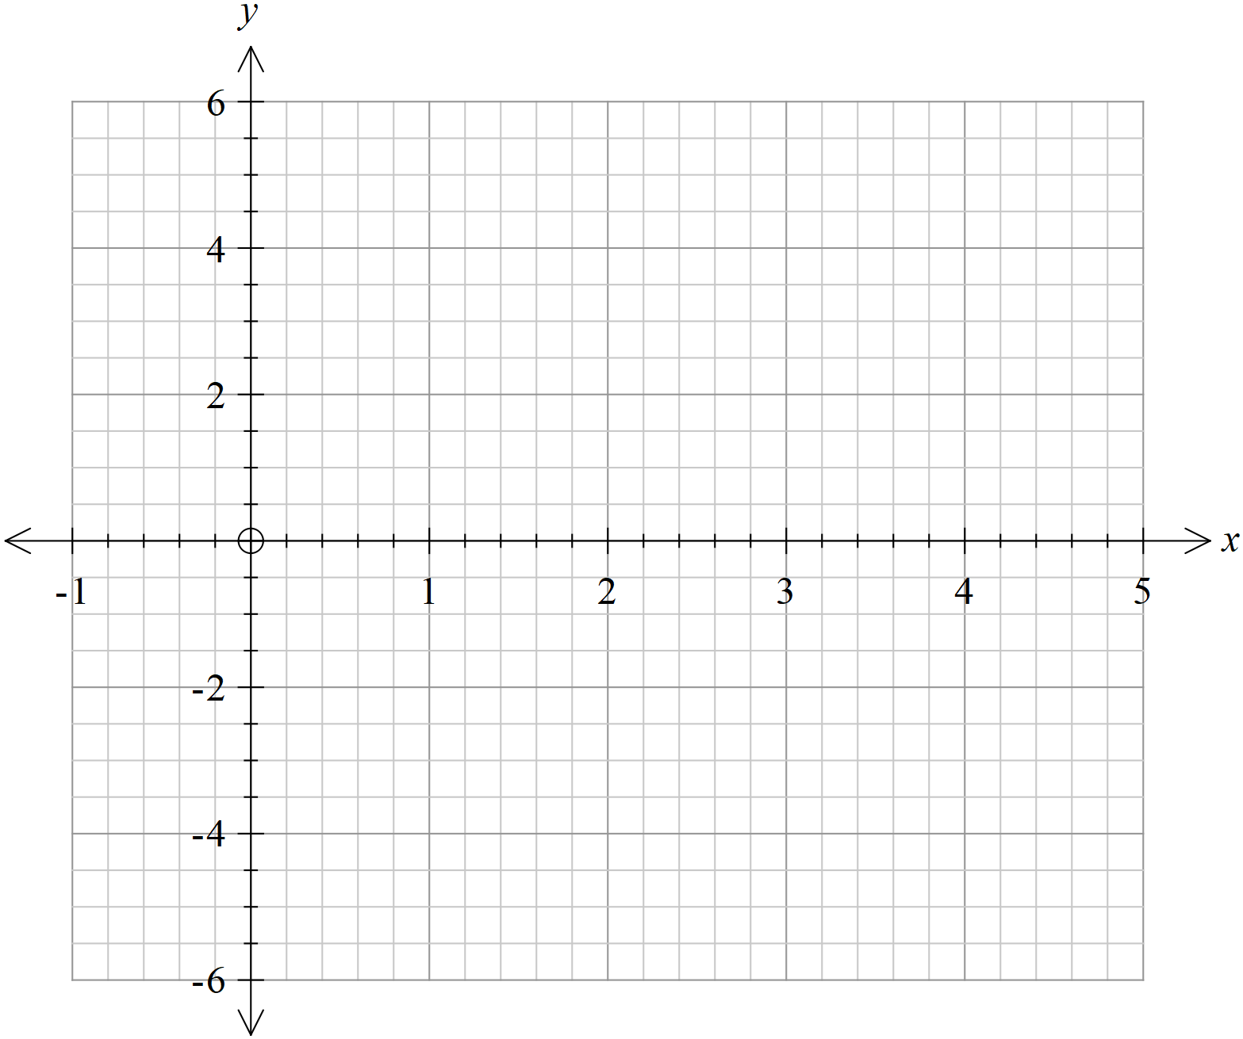

1. Describe the transformation of each graph from 
2. Are the transformations what you expected? Why/why not?
3. Let . Write each of the functions graphed above in terms of .